Description :
The ECO-45 is a high efficiency pellet stove. This model is EPA certified and is approved for installation in mobile homes. Its low clearances to combustible materials make it a safe bet in the Medium pellet stoves category.

Features :
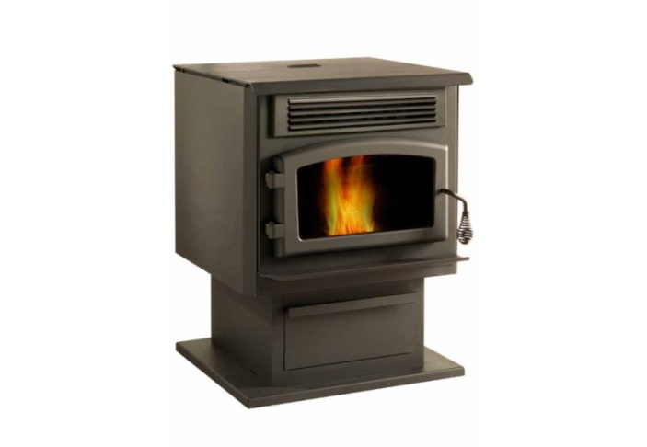
- Model # : DP00045
- High-efficiency stove EPA approved
- Recommended Heating Area (sq. ft.) : 500 - 2,000
- Electronic igniter
- Thermostatic or manual mode
- Safe and removable handle
- Automatic or manual adjustment of combustion air supply
- Mobile Home Approved
- Color : Metallic black
- Model : Pedestal
- Easy-to-access ash drawer
- Optimal efficiency : 78 %
- Emissions (grams / hour) : 1.8 g/h
- Burn Rate : 1.3 - 5.5 lb/h
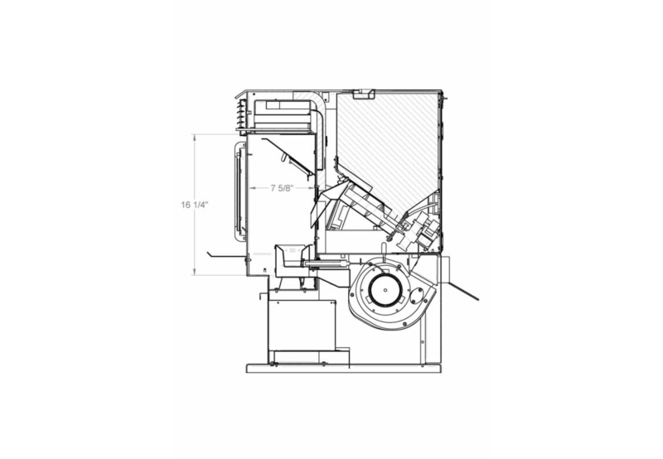
- Tested or/and listed as per applicable standards by : Intertek
